PES2UG21CS478, Sanskar Khatri

Output for program 1:

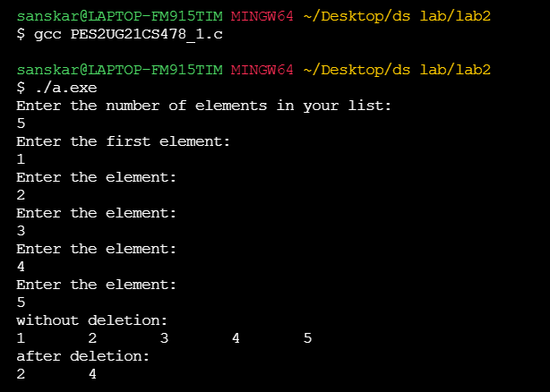

Output for program 2:

